Globally Distributed Computation over the Internet – The POPCORN Project
Noam Nisan, Shmulik London, Ori Regev, Noam Camiel
{noam,londons,regev,demian}@cs.huji.ac.il
Institute of Computer Science, Hebrew University
Jerusalem, Israel

Abstract
The POPCORN project provides an infrastructure for globally distributed computation over the whole Internet. It provides any programmer connected to the Internet with a single huge virtual parallel computer composed of all processors on the Internet which care to participate at any given moment. A market-based mechanism of trade in CPU time underlines the system as to motivate processors to provide their CPU cycles for other peoples’ computations. “Selling” CPU time is as easy as visiting a certain web site with a Java-enabled browser. “Buying” CPU time is done by writing a parallel program, using our programming paradigm (and libraries). This paradigm was designed as to fit the situation of global computation. A third entity in our system is a “market” for CPU time, which is where buyers and sellers meet and trade. The system has been implemented and may be visited and used on our web-site: http://www.cs.huji.ac.il/~popcorn.

1. Introduction
There are currently millions of processors connected to the Internet. At any given moment, many if not most of them are idle. An obvious and appealing idea is to utilize these computers for running applications that require large computational power. This would allow what may be termed “global computing” – a single computation carried out in cooperation between processors worldwide.
In the context of a single local network, this idea has been successfully attempted by rather many systems by now, especially due to the influence of the work done in “Network of Workstations” (NoW)[2]. However, the situation is more complicated when it comes to the whole Internet. First, there are major technical difficulties due to code mobility, security, platform heterogeneity, and coordination concerns. The recent wide availability of the Java programming language [3] embedded in popular browsers goes a long way in solving many of these technical difficulties by providing a uniform and secure mobile code platform. However, even after the technical difficulties are solved, we are left with significant problems that are inherent to global computation. At least two fundamental differences exist between global computation (like POPCORN) and locally distributed computation (like NoWs).
The first difference is a matter of scale: The Internet is much more “distributed”: The communication bandwidth is smaller, the latency higher, the reliability lower. Processors come and go with no warning and no way to control them. On the positive side, the potential number of processors is huge. We believe that while the Internet currently cannot hope to serve as a totally general-purpose efficient parallel computer, it can still provide excellent computational resources for a wide variety of computational problems. We sketch some of these applications in section 4.
A more interesting difference is due to the distributed ownership of the processors on the Internet. Since each processor is owned and operated by a different person or organization, there is no a-priori motivation for cooperation (why should my computer work on your problem?). Clearly a motivation for cooperation (such as payments for CPU time) must be provided by a global computing system. In addition processors on the Internet may be malicious or faulty, and thus should verify each other’s results and need be protected from each other.

POPCORN Overview
POPCORN's basic function is to provide any programmer on the Internet with a simple virtual parallel computer. This virtual machine is implemented by utilizing all processors on the Internet that care to participate at any given moment. In order to motivate this participation, a market-based payment mechanism for CPU-time underlines the whole system. The system is implemented in Java and relies on its ubiquitous “applet” mechanism for enabling wide scale safe participation of remote processors. A preliminary poster report of our implementation appeared in [4]; the system may currently be used on our market web site [5]. Further, and up to date, information can be found on our web site [1].
There are three distinct entities in the POPCORN system:
- The parallel program written (in Java) using the POPCORN paradigm and API. This program acts as a CPU-time “buyer”. The programming paradigm was designed as to fit “global computing”.
- The CPU-time “seller” which allows its CPU to be used by other parallel programs. This is done as easily as visiting a web-site using a Java-enabled browser, and requires no download of code.
- The “market” which serves as a meeting place and matchmaker for buyers and sellers of CPU-time.

The POPCORN programming paradigm, used by the buyer program, achieves parallelism by concurrently spawning off many sub-computations, termed “computelets”. The POPCORN system automatically sends these computelets to a market (chosen by the user), which then forwards them to connected CPU-time sellers who execute them and return the results. The matching of buyers and sellers in the market is dynamic, is done according to economic mechanisms, and results in a payment of the buyer to the seller.

The system is clearly intended for very coarse-grained parallelism. The efficiency is mostly determined by the ratio between the computation time of computelets to the communication effort needed to send them and handle the overhead. To achieve high efficiency, computelets should be relatively heavy in terms of computation time. Currently, seconds of CPU-time per computelet are a minimum, and tens of seconds seem more typical. For very large-scale computations, even hours make sense.

Related Work
As mentioned previously, the basic idea of “stealing cycles” on local networks is well known, and is the basis for “Network of Workstations” [2] and many related projects. The same idea over the Internet, with its different considerations, is much less developed. Several projects have designed tailor-made systems for globally solving specific problems, most notably factoring [6] and code breaking [7]. The communication in these systems was actually done using email! Some systems were designed which take into account some aspects of global computation. The SPAWN [8] system provides a market mechanism for trade in CPU-time in NoWs. The Legion [9] project aims at wide area sharing of CPU-time, but lacks market mechanisms and automatic participation.
Only recently with the availability of the Java language has a general mechanism for global computing been possible. The basic idea of using the Java virtual machine embedded in browsers to execute, using the “applet” mechanism, sub-computations of a remote computation, was recently independently suggested by several authors. Some of these authors have implemented some specific algorithm using Java and applets. A typical example of such an implementation can be found in a popular article [10]. These implementations have been for a single specific problem and do not attempt providing a general system. Several general systems using Java have been designed, but each of them concentrates on a single aspect of global computation. The Charlotte [11] system and the ParaWeb [12] systems provide an emulation of a shared memory parallel computer (and are thus probably more appropriate to LANs), however lack any trade mechanisms. The SuperWeb [13] system provides a market for CPU time, but does not provide a programming paradigm on top of it.

Paper Organization
Section 2 describes and justifies the programming paradigm. Section 3 outlines the economic mechanisms which underline the system. Section 4 sketches some of the implemented and intended applications of the system. Section 5 shortly describes our implementation, and section 6 sketches our current research efforts.

2. A Programming Paradigm for Global Computing

Requirements
Let us consider the situation in globally distributed computation. The application programmer has his own processor, which is trusted and available for his use, and wishes to utilize in addition as many processors from all over the internet as possible. He has only very little control over these processors: their power and number is unknown, they come and go with no warning and may not be trust-worthy. In addition, the communication latency to these processors may be high, the bandwidth low, the reliability low and they may not be able to freely communicate with each other. Finally, the programmer may need to pay for these processors’ services in some form. The bright side though is that the potential number of processors may be huge.
Let us enumerate some of the characteristics of the programming paradigm, which thus seem to be required:
- Distinction between the central (local, trusted, free) computer and the remote ones.
- Transparency of the number and type of remote processors.
- Communication is expensive and should be well regulated.
- The remote computations should be very well encapsulated as to allow their verification, re-computation, as well as well-defined pricing.

The Basic Paradigm
A POPCORN application proceeds along a single main thread (which runs on the local processor). This thread keeps spawning sub-computations to be executed remotely. Each such sub-computation is executed asynchronously on some remote processor. A “Computelet” object encapsulates a remotely executed sub-computation. The Computelet is transmitted to the remote computer and gets executed there. We should emphasize that a computelet is a true object: it includes both the code to be executed as well as the data that this code operates on. The Computelet gets constructed at the local host, is sent to a remote host, and a pre-specified method gets executed there. The result, which can be any object, is then sent back to the local host.
The distributed POPCORN program deals with a somewhat higher-level abstraction than the Computelet; an object termed a “Computation Packet”. The heart of a computation packet is indeed the computelet that executes its main function. However, the computation packet encapsulates in addition all information regarding the local processing of this computelet: How it gets constructed, the price offered for it, how it is handled locally when the answer arrives, how it is verified, what if the remote computation fails somehow, etc. When a computelets’ result arrives, the enclosing computation packet receives an event notifying it of this and handles the result. This, in turn, may result in new computation packets getting constructed. Full details can be found in the POPCORN tutorial [16].
The computelet mechanism is syntactically similar to RMI, remote method invocation [14] (the object oriented variant of RPC [15]). This similarity masks however a basic semantic difference. In RMI the remote processor provides the code for the message invocation (the “service”); a computelet contains the code to be executed remotely. In RMI, the identity of the processor executing the code (i.e. providing the service) is known to the invoking one, and is important; computelets, on the other hand, are not at all aware of the location in which they execute. In RMI, the data is communicated as arguments; in computelets, it is part of the computelet object itself. Finally we should mention that RMI is usually synchronous while a computelet returns asynchronously. This eliminates any need for explicit use of any other types of concurrency, and provides a very easy event-driven model of programming.
A computelet may be considered to be a very restricted type of a software agent: like an agent it originates at one computer, travels the net with code and data, and executes at another. Unlike a general agent, a computelet cannot travel further, has a limited lifetime, is unaware of its location, and cannot communicate freely.

Technical Details
Technically, in the simplest form, a POPCORN application programmer is expected to subclass the two basic classes: popcorn.ComputationPacket and popcorn.Computelet. In the computelet subclass he must override the Computelet.compute() method with the code to be executed remotely. In the computation packet subclass he overrides the ComputationPacket.completed() method with the code which handles the results when they arrive. In addition, a main program is written which generates the computation packets needed for the whole computation. Below we list an example of a complete POPCORN program that finds the maximum of a function over some domain using simple brute force search of all possibilities.
Full technical details can be found in the POPCORN tutorial [16].

Import popcorn.*;  public class FindMaxPacket extends  ComputationPacket {  static int maxarg;  public static void main(String[] args) {  maxarg=0;  for (int a=0; a < 10000; a+=100)  new FindMaxPacket(a,a+99).go();  collectAll();  System.out.println(maxarg);  }  public FindMaxPacket(int from, int till) {  super(new FindMaxComputelet(from,till));  }  public void completed() {  update(((Integer)getResult()).intValue());  }  static synchronized void update(int candidate){  maxarg = (FindMaxComputelet.g(candidate) >  FindMaxComputelet.g(maxarg)) ?  candidate : maxarg;  }  } | Class FindMaxComputelet implements Computelet {  private int from,till;  public FindMaxComputelet(int from, int till){  this.from=from; this.till=till;  }  public Object compute() {  System.out.println("computing...");  int maxarg=from;  for (int x=from; x<=till; x++)  maxarg = (g(x)>g(maxarg)) ?  x : maxarg;  return new Integer(maxarg);  }  // the function we want to maximize  public static int g(int x) {  // ...  }  }
Figure 1: A complete Popcorn program for finding the maximum of a given function.

Failure and Verification
Throughout the computation, computelets are sent out and their results returned. The order by which they return, and the time lag until they do so are not predictable. The main program must thus be written in an asynchronous manner so it can progress well despite unpredictable order of computelets’ result arrival. The situation is actually even worse: computelets may not return at all due to communication breakdown, remote processor failure, etc. The POPCORN system detects such a situation (using timeouts or other information available from the OS) and informs the program when a computelet is such lost. The POPCORN application programmer is, thus, promised the following well-defined semantics: for each computelet sent, either an answer arrives (and then the “completed()” method of the enclosing computation packet is called), or a notification of failure is given (by calling the “failed()” method of the enclosing computation packet). The simplest thing to do in this second case is to simply re-send the computelet for computation, likely to a different processor. Alternatively, the main program may decide that it can live without this computelets’ result, and simply ignore it.
A more problematic situation may occur when a result arrives, but is incorrect (i.e. the computelets’ code was not executed correctly on the remote computer.) This may happen due to bugs in the remote processors’ implementation of Java, due to deliberate cheating by the remote processor, or due to communication problems of various sorts. Programs that need to be protected from such errors must verify the correctness of the computelets’ answer. It is currently the programmers’ responsibility to do this verification when it is needed. Here are several general possibilities for such verification:
- Send out each computelet several times and check equality of results. If a well-defined penalty for cheating is agreed by all participants, then random spot checks (of, say, one packet every hundred) will suffice.
- Some computelets may return answers that are easily verified correct. E.g. a computelet, which solves an equation using some complex method, may be easily verified by plugging the solution into the equation. In other cases a modification of the computelet to return some extra information (like a NP-type proof) would make verification easy.
- A general theory of how to use unreliable sub-computations to obtain reliable results has been developed (self-testing and self-correcting computation) [17][18][19]. Its theoretical results should be practically applicable in many cases.
- The computelets may be designed in a way that certain characteristics of the answer are known in advance to the main program, but hard to deduce just from the computelet code. In these cases, an answer that has these characteristics may be assumed correct.

Robust Programs
We have found that in many cases computelet results need not be verified and instead the program may be designed in advance as to be robust against incorrect results of a limited number of computelets! This statement should be interpreted in a relative sense: very minor and easy verification may suffice in order to obtain an almost perfect final result. We strongly feel that, when possible, programs should be designed this way. While this statement sounds surprising, we would like to note that most of the applications of our system that we describe in section 4 do fall naturally into this category! An added benefit of such programs is that they are also automatically resilient to losses of small numbers of computelets.
Let us give a simple example of this claim, using the code example shown above. In this example, a maximum value of a function g(x) was searched for over some domain. Each computelet searched a sub-domain and returned the maximum in its sub-domain. Notice that two types of errors are possible for such a computelet: the first is missing the sub-domain maximum, and the second is “inventing” a phantom maximum. In cases where maxima are not too rare and different from each other in value, the first type of error causes only a small problem: the optimal maximum may be missed, and a slightly sub-optimal one will be found instead – for many applications this could suffice. The second type of problem is more serious since a totally wrong answer may be found. However, note that the second type of error is easy to catch, as long as the location of the maximum, x, is returned and not just the value, g(x). Indeed this is exactly what the code example above does, and thus the program coded above is automatically protected from this serious type of error.
With just slightly more effort, even the first type of error may be taken care of: instead of partitioning the domain to disjoint sub-domains we may let each computelet search through a random subset (of a fixed size) of the domain. The total number of computelets should be such that the whole domain is covered by more than one computelet. This will somewhat increase the total amount of work, but will guarantee the correct answer as long as at least one of the computelets that were assigned the location of the maximum did not err. We should add here a general remark about using randomization in computelets: the computelet should normally be totally deterministic so that its results can be conclusively checked for correctness (e.g. if the “case goes to court”). If randomization is needed, then a pre-defined pseudo-random generator should be used, with its initial seed chosen (randomly) by the main program.

Higher Level Organization
The paradigm we have introduced results in parallel programs that resemble event-driven programming more than normal concurrent programs. We find this an advantage due to the simplicity of the event-based model. We have extended the paradigm as to allow the whole program to be recursively designed this way. We define a “CompoundComputation” class which asynchronously spawns sub-computations (which may themselves either be computation packets or recursively, compound computations). More details can be found in the POPCORN tutorial [16].
A note on synchronization is in place here: computelets execute asynchronously and do not require synchronization with each other. On the other hand, handling computelet answers usually does involve updating some shared data-structure for which access to should be synchronized – this shared data-structure will usually be synchronized to the level of the direct parent compound computation.

Debugging

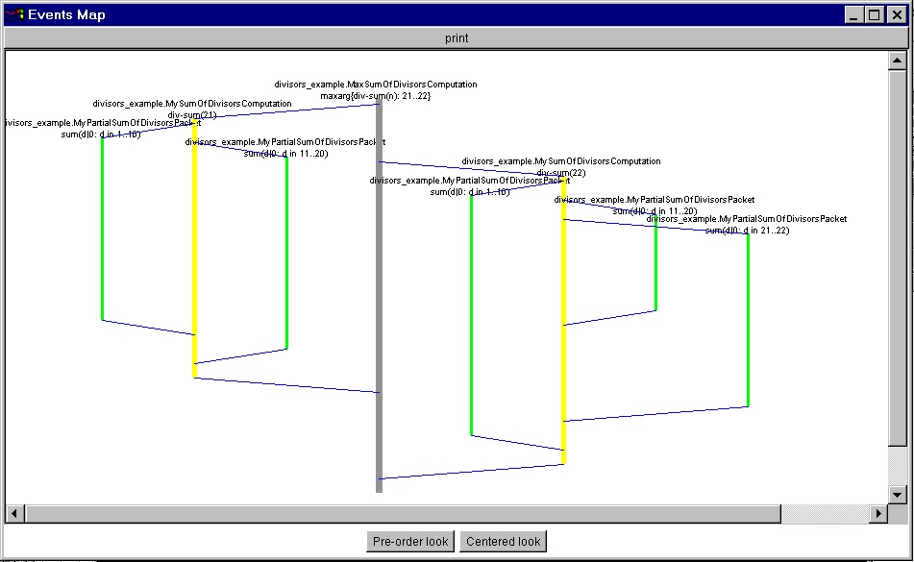
Concurrent programs are notoriously hard to debug. POPCORN programs are somewhat easier due to their simplified concurrency model, yet they still are hard to debug. We have built two debugging aids. The first is a mock computelet distributor, which executes them locally, instead of sending them for remote execution. The second is a tool that draws the tree of spawned computelets.

Figure 2: A simple debugging utility for Popcorn

3. A Micro-Economy of CPU time
Processors that are to “donate” their CPU time are to be motivated for this. There are many possibilities for such motivation starting from just friendly co-operation ranging to real cash payments. In any case, any general enough mechanism will result in what may be clearly called a market for CPU time: the process by which seekers (which are now buyers) and providers (which are now sellers) of CPU time meet and trade. It seems very likely that such totally automated electronic markets will play a large role in many forms of internet cooperation (not just for CPU time!), and that general mechanisms for such markets need to be developed and understood.

The Goods
The first thing one must ask in such an electronic market is what exactly we are trading in. The answer “CPU time” is not exact enough since it lacks specifics such as units, differences between processors, deadlines, guarantees, etc. A basic tradeoff is between allowing the traders very specific description of the goods, and between maintaining a small number of uniform types of goods with larger market size. Our approach has been to emphasize uniformity in the initial implementation, but building the infrastructure to allow specialization in later versions (with hopefully larger market activity.)
Our basic goods are the “JOPs” – Java Operations. This is the Java equivalent of the commonly used, though imprecise, FLOPS. Of course, there are different types of Java operations, with different costs in different implementations, so we define a specific mix of computations and use this mix as a definition. Each computelet takes some number of JOPs to execute, and the price for a computelet is proportional to the number of JOPs it actually took to compute remotely. This is measured (or actually, approximated) using a simple benchmark we piggyback on each computelet. The benchmark functions as follows: Its core is a thread repeatedly performing and timing some computation chosen to have the correct mix of instructions. This benchmark is run in separate high priority thread. Most of the time this thread is sleeping and thus takes no CPU time, but when it periodically awakes, then due to its high priority, it preempts all other threads and thus provides a true reading of the underlying Java implementation speed. This information is reported back to the market.
We have found that this mechanism works well. Still, two main disadvantages are obvious: first, the benchmark is run on the sellers’ computer and this computer may cheat and report higher numbers. (Such cheating entails modification of the browser used on the sellers’ side, but is still possible with some effort.) Second, it is imprecise by nature, as well as has an overhead. We have thus also provided a second type of “good” which can be traded: simply the computation of a single computelet. This does not require any benchmarking, but may be troublesome for the seller since he has no a-priory control over the of computation time of the computelet. Still, this simple mechanism is very proper in many situations such as the case of a repeat buyer of CPU time, the case of “friendly” non-financial transactions, or the case where computelet size is set administratively.

The Money
One may think of several motivations for one processor to provide CPU-time to another:
- A friendly situation where both processors belong, e.g., to the same organization or person.
- Donation.
- Straightforward payment for CPU time.
- Barter – getting in return some type of information or service.
- Loan – getting CPU time in return in some future date.
As in real life, all of these motivations, as well as others, may be captured by the abstract notion of money. This “money” may be donated, traded, bartered, loaned, converted to other “currency”, etc.
This is the approach taken in POPCORN: we define an abstract currency called a popcoin. All trade in CPU time is ultimately done in terms of popcoins. In our current implementation popcoins are just implemented as entries in a database managed by the market, but they can be easily implemented using any one of the electronic currency schemes. Each user of the POPCORN system has a popcoin-account, paying from it for CPU time required, or depositing into it when selling CPU time. The market automatically handles these financial aspects throughout the computation. Once this mechanism exists, all of the motivations described above are obtained by administrative decisions regarding how you view popcoins: If you want to get true payment for CPU time just provide conversion between popcoins and US$ (we do not…). If you are in a friendly situation just ignore popcoin amounts. If you want to loan CPU cycles, just buy CPU time with popcoins and at another time sell your CPU time for popcoins.

Buying and Selling CPU time
The programmer writing a parallel POPCORN application is in fact buying CPU time. Basically, the parallel program must offer a price for the computation of each computelet. The payment is executed on sellers’ return of the answer to the market, and is deducted from the buyers’ account in the market (which must be specified before the computation can proceed). Technically, each computation packet constructs a “Contract” object that encapsulates the offer. The contract specifies the prices offered, whether the price is per computelet or per JOP, and the market mechanism required for this transaction (see below). The contract may be hard-coded into the program; alternatively we provide a user-level tool for specifying the contract.
Selling CPU time is done as easily as visiting a page on the web with a Java-enabled browser. This page contains an applet that starts working on the sellers’ computer and which repeatedly receives computelets and computes them. In the most direct form, a seller visits the market’s web site, where he is asked to provide his account information (name and password). Once this information is provided, a “start computing” button starts the CPU-selling process and all popcoins earned are deposited into this account. By default, each seller simply auctions his CPU-time to the highest bidding (per-JOP) prospective buyer. Optionally, the seller may also enter his preferences for the trade, e.g. specifying pricing information (see below).
An alternative mechanism exists which does not require the seller to hold an account, or to be compensated in popcoins. In this variant a “seller” visits a web page that is of some interest to him. In addition to this interesting information, the page contains the “POPCORN logo”. This logo has two main functions. First, it is an applet that receives computelets and executes them. Second, this logo explicitly informs the user that this is going on. In this situation the seller is in fact bartering his CPU time for the information on the web page. This can be an on-line game, a picture, or any other type of information. We maintain a little “gallery” of such web-pages (currently we have a couple of simple games as well as some digital art. [20])
We have provided a general mechanism by which any person who has such “interesting” online information may get, in effect, paid for this information with popcoins, and become, what we term, a POPCORN “publisher”. Such a publisher embeds the POPCORN logo in his page, which results in the automatic selling of CPU cycles of anyone visiting his page. All the popcoins earned for the computations done by these visitors go to the publishers’ (previously opened) popcoin account. In effect we have a 3-way trade here: the seller provides CPU time and gets information; the publisher provides information and gets popcoins; and the buyers provide popcoins and get CPU time. Exact details on how to become a publisher can be found at [21].

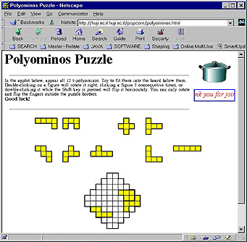
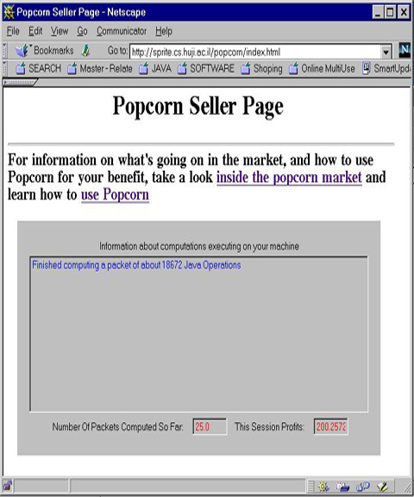

Figure 3 (left): A game web page with the POPCORN logo (top right corner).
Figure 4 (right): POPCORN seller web page.

The Market
The most immediate function of the market is to simply serve as a well-known location which buyers and sellers come to, instead of trying to look for each other in the whole Internet. (There can be many different markets, but supposedly each is in a “well-known” location.) Obviously this makes the market a bottleneck of the whole system, but as long as the computation done by each computelet is CPU-time-consuming enough relative to the market overhead, a single market can handle large numbers of buyers and sellers. The market is a trusted intermediary and is responsible for matching buyers and sellers, for moving the computelets and results between them, as well as for handling all payments and accounts. The implementation of the market involves a server that buyers can connect to as clients, as well as a set of web pages with applets embedded in them (and a supporting server) for the sellers to connect to. The most important aspect of the market is to match buyers and sellers according to economic criteria. We have two different mechanisms currently available. They are handled as separate internal markets and each buyer and seller chooses which of these mechanisms he desires (in addition to choosing whether the payment is per JOP or per computelet).
The first mechanism is the Vickrey auction [22]. Here, the CPU-time of the sellers is auctioned among current buyers. This auction is performed whenever a new computelet is to be sent to this seller. In this case the seller need not specify any pricing information at all, and the buyer needs to specify a simple price. The catch in a Vickrey auction is that the price paid by the buyer, is not the one he offered but rather the second highest price offered in the auction. The well-known [22] advantage of Vickrey auctions relative to normal auctions is that a dominant strategy for each bidder is to bid the true worth to him of the good. In an electronic market, this existence of a simple dominant strategy, which need not take into account various tactical considerations, is very important due to the fact that these tactical considerations are usually hard to define in advance.
The second mechanism we provide is (a slightly simplified version of) the double auction [23][24]. In this case both buyers and sellers offer a low price and a high price, as well as a rate of change. The sellers start with an offer of the high price, and offer which automatically gets decreased, at the specified rate, until a buyer is found (or the low price reached). Similarly, buyers start at the low price, and their offer automatically gets increased until a seller is found (or the high price is reached). When a buyer “meets” a seller the buyers’ computelet is sent for execution on the sellers’ machine and the payment is at meeting price. This mechanism results in stock-market-like behavior, and is very dynamic and easy to define and implement.
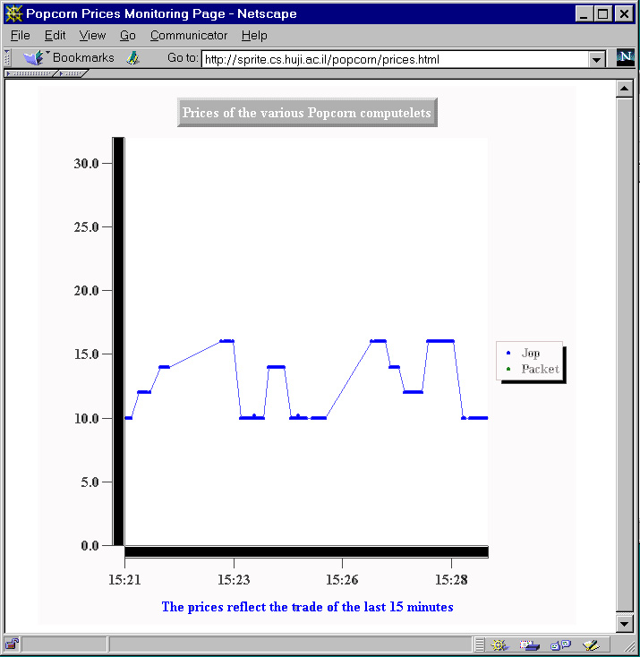
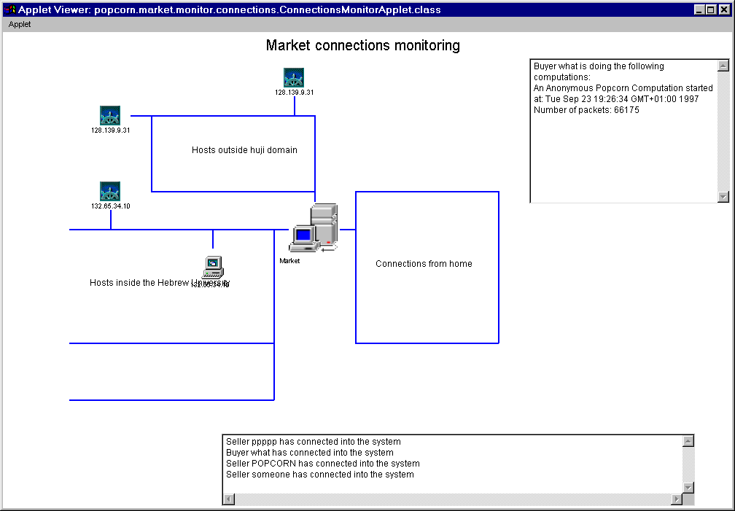
In our limited experience both mechanisms seem to work well in terms of finding economically efficient, as well as computationally efficient matchings, in a dynamic situation. We cannot claim, however, to have complete understanding of market dynamics and strategies, beyond the general analysis known for these mechanisms.
Figure 5 (left): computelet price changes.
Figure 6 (right): A snapshot of connections to the market.

4. Applications
We list here several of the applications of the POPCORN system. These applications are ones that we feel can utilize well the CPU-time available on the Internet using the POPCORN system. A common characteristic of them all is that they are “loosely coupled”: they can be broken into rather independent sub-computations, each heavy in terms of CPU time, but relatively light in terms of data transfer.

Brute Force Search and Code Breaking
The most obvious types of applications are to simply try out, in parallel, many different possible solutions for a problem until one is found – a strategy known as brute-force search. For many problems, no better algorithmic solution is known, and these are obvious candidates for POPCORN. Many NP-complete problems fall into this category. It should be noted that such POPCORN programs are easily made robust, in the way shown in section 2.
Another class of tasks which fall into this category are various code-breaking problems, and indeed these applications have already been globally computed in special purpose efforts [6][7]. Several clever improvements over brute-force search are known – ones that still fall within the POPCORN paradigm. In particular, Lenstra [25] presents some factoring algorithms (good for breaking public key crypto-systems such as RSA), and bit-slicing algorithms have been proposed [26] for breaking DES and other classical cryptography systems.
As a simple example of brute-force search using POPCORN we have implemented a program which attempts improving the lower bound on the 5th Ramsey number [27], by trying to find a large graph without a 5-clique or 5-independent set [28]. (No luck yet…)

Simulated Annealing and Genetic Algorithms
A great many algorithms from the “simulated annealing” family [29] may be loosely described as by the following generic outline: start with some initial sub-optimal solution, and then iterate over a basic step which tries to locally improve it until a good enough solution is found. (This basic step is usually randomized, depends on some changing “temperature” parameter, etc.) While this may seem highly sequential, its randomized nature allows pretty efficient parallelization by maintaining several intermediate solutions, and randomly, in parallel, locally improving each of them. The following pseudo-code snippet outlines a simple POPCORN-based implementation of simulated annealing. Note that this strategy is quite robust. Such an algorithm for solving the traveling salesman problem has been implemented using POPCORN [30].
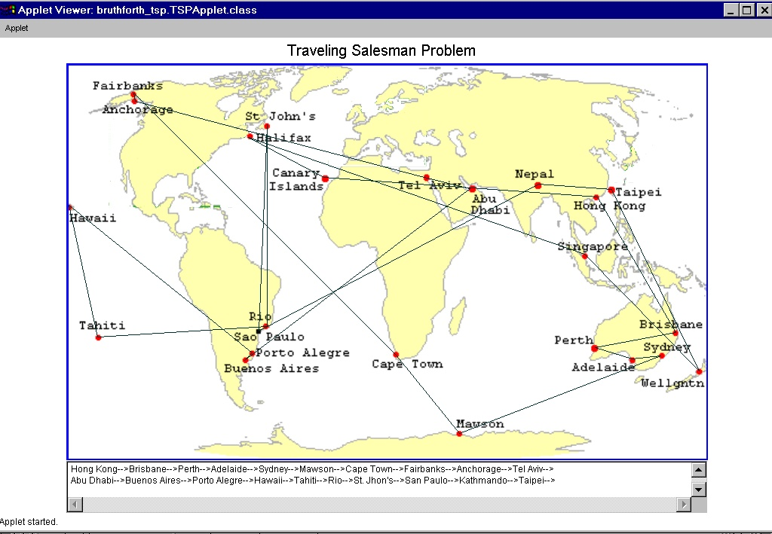
Figure 7: A POPCORN implementation of simulated annealing for TSP

Start with k initial solutions: x1 … xk
Repeat:
In parallel remotely improve each solution
Keep k best solutions
Until good enough solution found.

To remotely improve (x):
Repeat l times a basic improvement step

This basic parallelization idea works (with some modifications) also for genetic algorithms. On one hand the situation is easier since a genetic algorithm maintains a population of solutions which can naturally be handled in parallel, and on the other the situation is more complicated since communication of populations is more expensive than that of a single solution.

Planning and Game-Tree Evaluation
Another class of problems which require massive computation are those which involve look-ahead into a large tree of possibilities. Many PSPACE-complete problems fall into this category. Computing strategies for various games (e.g. chess), or planning strategies to achieve some goal (e.g. robot motion planning, or other AI tasks) are common examples. In these cases it is clear that many separate branches of the tree can be independently searched in parallel. Some care is required to ensure that common optimizations (such as alpha-beta pruning) can be adopted.

5. Implementation
We have implemented the system in pure Java and have a demo market online on the web which can be visited and used [5]. More information can be found on our web site [1]. We have only had small-scale tests of the system, mostly due to the fact that, as we use the Java 1.1 API, only very up-to-date browsers (Netscape 4.03 or Sun’s appletviewer) work with it. The system code is pretty compact (30K lines of Java code) mostly due to our heavy use of advanced features of the Java API (serialization, GUI, class loading, etc.). We are very happy with Java as a programming language and we do feel that it has significantly reduced our debugging efforts. We do however note that stability of Java is not here yet.
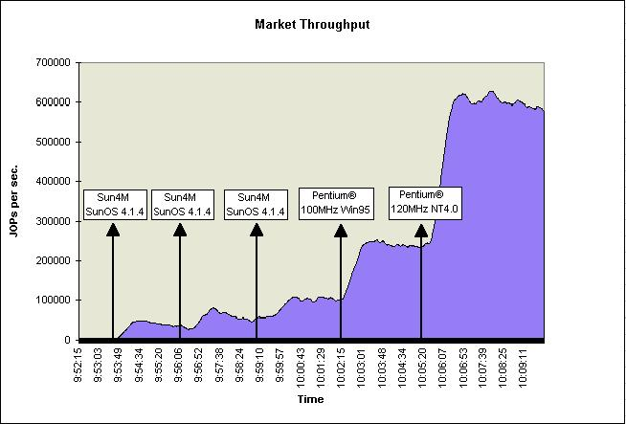
We have made no optimization efforts at all, yet (such as optimizing protocols, caching, reducing thread usage, etc.) We have made preliminary performance measurements, of interpreted (not compiled) code, burdened with heavy monitoring and debugging. These measurements thus serve mostly for comparison with each other. The overhead of market (which is the bottleneck) is 0.21 seconds per computelet, as measured with the market running on a 200MhZ Pentium PC with JDK 1.1. At a few seconds of CPU time per computelet we already get high efficiency. With such computelets, the following graph depicts the throughout of the system as more and more sellers of varying type and power are dynamically added to the market.

Figure 8: Buyer throughput as sellers are added

6. Ongoing Work
Throughout our implementation we were careful to design the system in a very general and modular way so it can serve as a test bed for future research and modification. Below we list our current research efforts with the POPCORN system.
- A network of markets: in the current basic scheme the central market is a bottleneck and the system does not scale. We are replacing the single market with a network of cooperating and competing markets.
- Shared objects: our current implementation does not allow computelets to communicate with each other. We are working on a POPCORN variant, intended for higher bandwidth communication, which allows computelets to share objects.
- Market analysis: we are trying to understand the market dynamics when large number of buyers and sellers meet, both using analytical methods (game theory, economics, online algorithms), and using experimental methods.
- Verification support: verification is currently the programmers’ duty. We are working on various tools to take on this burden.
- Higher level languages: We would like higher level languages than the POPCORN API, at least for specific domains of applications.

References
- The POPCORN homepage, http://www.cs.huji.ac.il/~popcorn.
- Thomas E. Anderson, David E. Culler and David A. Patterson, “A Case for Networks of Workstations: NOW”, IEEE Micro, Feb, 1995, http://now.cs.berkeley.edu.
- JavaSoft homepage, http://www.javasoft.com/index.html.
- Noam Camiel, Shmulik London, Noam Nisan and Ori Regev, “The POPCORN Project -- An Interim Report, Distributed Computation over the Internet in Java”, Proceedings of the sixth international World Wide Web conference (CD version), 1997, http://www.cs.huji.ac.il/~popcorn/documentation/www6/poster.html.
- The Popcorn Market homepage, http://www.cs.huji.ac.il/~popcorn/use.html.
- RSA Factoring-by-web homepage, http://www.npac.syr.edu/factoring/info.html.
- RSA DES Challenge crackers, http://www.frii.com/~rcv/deschall.htm.
- Carl A. Waldspurger, et al. "Spawn: A Distributed Computational Economy", IEEE Trans. on Software Engineering, Vol. 18, No. 2, Feb 1992.
- Andrew S. Grimshaw, Wm. A. Wulf and the Legion team, “The Legion Vision of a Worldwide Virtual Computer”, Communications of the ACM January 1997/Vol. 40, No 1, http://www.cs.virginia.edu/~legion/index.html.
- Laurence Vanhelsuwe, “Create your own supercomputer with Java” JavaWorld Online Magazine, Jan 1997, http://www.javaworld.com/jw-01-1997/jw-01-dampp.html.
- A. Baratloo, M. Karaul, Z. Kedem and P. Wyckoff, “Charlotte: Metacomputing on the Web”. Proceedings of the 9th Conference on Parallel and Distributed Computing System, 1996.
- Tim Brecht, Harjinder Sandhu, Meijuan Shan and Jimmy Talbot, “ParaWeb: Towards Word-Wide Supercomputing”, Proceedings of the Seventh ACM SIGOPS. European Workshop, Connemara, Ireland, pp. 181-188. September 1996.
- A. D. Alexandrov, M. Ibel, K. E. Schauser and C. J. Scheiman, “SuperWeb: Towards a Global Web-Based Parallel Computing Infrastructure”, 11th International Parallel Processing Symposium (IPPS'97), Geneva, April 1997.
- Java™ Remote Method Invocation, http://java.sun.com/products/jdk/rmi/index.html.
- Birrel, A.D. and Nelson, B.J., "Implementing Remote Procedure Calls", ACM Trans. on Computer Systems, vol.2, pp. 39-59, Feb. 1984.
- Shmulik London, The Popcorn Tutorial, http://www.cs.huji.ac.il/~popcorn/developer/tutorial/index.html.
- Blum M., Luby M. and Rubinfeld R., "Self-Testing/Correcting with Application to Numerical Problems", STOC 1990.
- Peter Gemmell, Richard J. Lipton, Ronitt Rubinfeld, Madhu Sudan and Avi Wigderson, “Self-Testing/Correcting for Polynomials and for Approximate Functions”, STOC 1991: 32-42.
- Blum, M. and Kannan, S., “Program correctness checking... and the design of programs that check their work”, STOC 1989.
- The Popcorn Gallery, http://www.cs.huji.ac.il/~popcorn/gallery/index.html.
- The Popcorn publisher homepage, http://www.cs.huji.ac.il/~popcorn/publisher/index.html.
- Vickrey William, "Counterspeculation, Auctions, and Competitive Sealed Tenders", Journal of Finance, March 1961, 16, 8-37.
- Wilson Robert, "Incentive Efficiency of Double Auctions", Econometrica, Sept. 1985, 53(5), pp. 675-90.
- Friedman Daniel, "On the Efficiency of Experimental Double Auction Markets", American Economic Review, Mar. 1984, 74(1), pp. 60-72.
- A. K. Lenstra, H. W. Lenstra, Jr., (eds.), “The development of the number field sieve”, Lecture Notes in Math, 1554, Springer Verlag, Berlin, 1993.
- Eli Biham, Adi Shamir, “The Next Stage of Differential Fault Analysis: How to break completely unknown cryptosystems”, Oct 30th, 1996
- Ronald L.Graham, Bruce L. Rothchild and Goel H. Spencer, “Ramsey Theory”, Johen Wiley & Sons, Inc., 1980.
- Shmulik London, 5th Ramsey Number POPCORN application, http://www.cs.huji.ac.il/~popcorn/developer/examples/ramsey/index.html.
- Kirkpatrick S., Gelatt C. D. and Vecchi M. P., “Optimization by simulated annealing”, Science 220(4598), 1983.
- Rivki Spira, Traveling Salesman POPCORN application, http://www.cs.huji.ac.il/~popcorn/developer/examples/rivki_tsp/index.html.

